TORRANCE CHORALE FRIENDS
Post Office Box 3201
Torrance, California 90510-3201
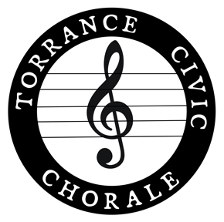
Holiday Celebration Concert
Featuring the Torrance Civic Chorale, the Torrance Jazz Singers
and the Palos Verdes Symphonic Band
Saturday, December 21, 2024
Program Advertisements

The Torrance Civic Chorale has provided the South Bay Community with exceptional choral music since 1961. By placing an advertisement in our concert program, your tax-deductible donation helps to maintain this inspiring community choral group while promoting your business in the community you serve.

Please do not miss this opportunity to showcase your commitment to serving the South Bay Community and your continued support for the cultural arts.

Advertisement Size | Rate
Business Card (2 X 3.5 inches – Landscape Format) | $25
Quarter Page (4.25 X 5.5 inches – Portrait Format) | $50
Half Page (8.5 X 5.5 inches – Landscape Format) | $100
Full Page (8.5 X 11 inches – Portrait Format) | $300

Please submit your camera-ready business card or advertisement with your check payable to Torrance Chorale Friends (note ad size on the memo line) directly to your Torrance Civic Chorale representative or by mail to the address listed at the top of this form. Payments can also be made to Torrance Chorale Friends on PayPal.

Ad submissions must be received no later than Friday, December 13th to ensure inclusion in the concert program. Email your ad copy (in *jpeg, *tiff, *png or *PDF format) to disneyjedi@aol.com, with the subject line TCC Disney Celebration Concert ad. For further information contact: Susan Culver Suhr by phone or text at 310.717.9332.

For more information about the Torrance Civic Chorale, please visit us at: http://www.torrancecivicchorale.net.

Torrance Chorale Friends is a 501(c)(3) nonprofit organization.
Our federal tax identification number is 95-3808603.

